
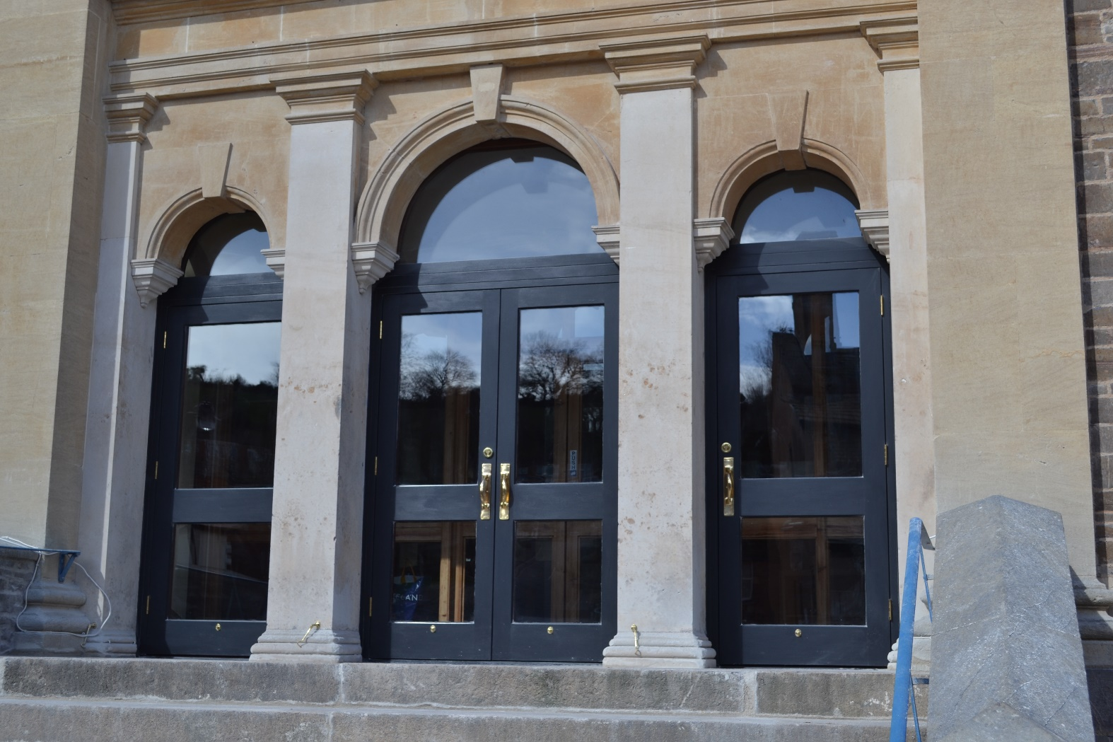

Crediton Congregational Manse Risk Assessment

Location of first aid kits:
Main Church -Fishtank Bar &
servery kitchen
Karis Hall – kitchen boiler cupboard
Manse – Church office 1st floor

Analysing the risk
To help analyse risk, Crediton Congregational Church uses a matrix scoring system. Numerical scores are given to the severity and likelihood of risks and these scores are multiplied to get a rating for the risk. This means the risk rating is a measure of the likelihood that harm from a particular hazard will occur, considering the possible severity of such an occurrence.
Risk = Severity x Likelihood
For the initial risk evaluation, consider the risks identified as the worst-case scenario before any controls are applied, then evaluate the risk when control measures are implemented.

 |  |  | FREQUENCY (Environment and Safety)
CONCEQUENCES | Environment | Safety | Likely  5  Occurs repeatedly,  Event expected | Probable  4  Not surprising, will occur several times | Possible  3  Could occur at some time | Remote  2  Unlikely to occur, although conceivable | Improbable  1  So unlikely that probability is close to zero
CONCEQUENCES | Catastrophic  5  National importance, major breach of legislation | Multiple Fatal  5  More than one fatality | 25 | 20 | 15 | 10 | 5
CONCEQUENCES | Very Serious  4  Significant effects, serious breach of legislation | Fatal  4  One fatality | 20 | 16 | 12 | 8 | 4
CONCEQUENCES | Major  3  Significant effects, contained within site | Major Injury  3  RIDDOR notifiable, major injury or over 7 days absence | 15 | 12 | 9 | 6 | 3
CONCEQUENCES | Moderate  2  Effects contained mainly on site, likely to be short lived | Minor Injury  2  Any lost time injury with up to 3 days absence | 10 | 8 | 6 | 4 | 1
CONCEQUENCES | Minor  1  Small to negligible effects | V. Minor Injury  1  Any injury without any significant lost time | 5 | 4 | 3 | 2 | 1

Hazard | Risk | Persons at Risk | Risk Level |  |  | Control Measures | Residual Risk
Hazard | Risk | Persons at Risk | L | S | DR | Control Measures | L | S | DR
Slips and Trips;  - Foodbank parcels on Tuesdays and Fridays  - Worn or unfixed carpet edges, rugs or doormats  - Trailing wires, cables or leads  - Poor lighting  - Variations in the level of floors (for example, ramps, steps)  - Cleaning activity making floors slippery (wet mopping, use of polishes, etc.),  - Spillages of food or drink (particularly in kitchen areas),  - Walk-in contaminant from adverse weather (for example, mud, rainwater, etc.)  - Ice on front steps and on footpaths and car park | Impalement/cuts;  Catastrophic bleed, Graze, Minor Bleeds  Musculo-skeletal;  Paralysis  Head Injury;  Concussion  Skull fracture  Hematoma | Staff,  Volunteers,  Congregation,  Visitors | 4 | 4 | 16 | - Ensure parcel delivery do not cause trip hazard. Segregate trip hazards from staff or Members of public during deliveries.  - Ensure carpets are in good condition and properly secured once a week or more if increased usage of facility.  - Ensure lighting levels are adequate and suitable.  - Display a ‘wet floor’ warning sign during cleaning operations and keep it in place until the floor is dry.  - Provide matting at main entrances to reduce slipping and increase friction for both wet and dry feet.  - Clean up food spillages in the kitchen immediately.  - During cold weather ensure footpaths, car park and steps are gritted | 2 | 2 | 4

Hazard | Risk | Persons at Risk | Risk Level |  |  | Control Measures | Residual Risk
Hazard | Risk | Persons at Risk | L | S | DR | Control Measures | L | S | DR
Hygiene;  - Not washing hands after going to the toilet. | Spread of Infectious Diseases:  The spread of infectious diseases  Pest Infestations:  Poor cleanliness can attract pests such as rodents and flies.  Allergies and Respiratory Issues: Dust, mold, and poor air quality due to inadequate cleaning can trigger allergies and respiratory issues.  Reputational;  Poor hygiene can create an unwelcoming atmosphere, negatively affecting the church’s image. | Staff,  Volunteers,  Visitors | 4 | 3 | 12 | Display hand wash signs to remind staff and visitors of proper hand hygiene. | 1 | 3 | 3

Hazard | Risk | Persons at Risk | Risk Level |  |  | Control Measures | Residual Risk
Hazard | Risk | Persons at Risk | L | S | DR | Control Measures | L | S | DR
Cleaning products;  Cleaning products not locked away and coming into contact with children or vulnerable people. | Respiratory Issues:  Products potentially exacerbating asthma and allergies  Skin Irritation and Burns: Direct contact may lead to dermatitis or exacerbate existing skin conditions.  Eye Irritation:  Sprays and aerosols can cause eye irritation or damage if they come into direct contact with the eyes.  Poisoning and Toxic Exposure:  Accidental ingestion of cleaning products, especially by children, can lead to poisoning, which may cause nausea, vomiting, or even more severe health issues. Inhalation of toxic fumes:  Headaches, dizziness | Staff,  Volunteers,  Congregation,  Visitors | 4 | 4 | 16 | - Eco-Friendly Products: Where possible use non-toxic, biodegradable cleaning products free from harsh chemicals like bleach and ammonia to minimize health risks.  - Proper Storage: Store cleaning products securely in a labeled, well-ventilated, and locked area out of reach of children and unauthorised personnel.  - Labeling and COSHH: Keep products in original containers with intact labels and provide COSHH Data Sheets for all products. Ensure accessibility to staff and volunteers.  - PPE: Provide and ensure the correct use of PPE, such as gloves, masks, and eye protection, for anyone handling cleaning products.  - Ventilation: Clean in well-ventilated areas by opening windows or using fans to reduce fumes, especially when using stronger chemicals.  - Emergency Preparedness: Ensure first aid kits are available, and staff are trained in emergency response for exposure to cleaning products. | 1 | 3 | 3

Hazard | Risk | Persons at Risk | Risk Level |  |  | Control Measures | Residual Risk
Hazard | Risk | Persons at Risk | L | S | DR | Control Measures | L | S | DR
Hot Water;  Burn, scalding, from hot taps kettle. | Burns and Scalds:  One of the most common dangers is burns or scalds from hot water. Even water at 120°F (49°C) can cause a serious burn in a matter of minutes, and at higher temperatures, burns can occur almost instantly. | Staff,  Volunteers,  Congregation,  Visitors | 4 | 4 | 16 | For Hot Taps:  - Adjust Temperature Settings: Set the maximum temperature of your water heater to 120°F (49°C) or lower. This reduces the risk of scalding.  - Check Water Temperature: Test the water temperature when heating system is inspected.  - Label Hot Water: Use clear stickers to warn of potential risks.  For Kettles:  - Use Kettles with Automatic Shut-Off: Kettles must have automatic shut-off feature when the water reaches boiling point.  - Keep Out of Reach: Place kettles out of reach of children or the vulnerable to prevent accidental tipping.  - Be Careful with Steam: Avoid placing your face or hands over the spout while pouring to prevent steam burns. | 1 | 3 | 3

Hazard | Risk | Persons at Risk | Risk Level |  |  | Control Measures | Residual Risk
Hazard | Risk | Persons at Risk | L | S | DR | Control Measures | L | S | DR
Heaters and boilers;  Burns and fire hazard. | Fire Risk:  Overheating or malfunctioning heaters can cause fires if they come into contact with flammable materials or are not properly maintained.  Burns:  Direct contact with hot surfaces or heated air can cause burns  Carbon Monoxide Poisoning:  Gas boiler, if not maintained properly, can emit carbon monoxide, a dangerous and potentially lethal gas.  Electric Shock:  Faulty electrical components or improper use of electric heaters can result in electric shock. | Staff,  Volunteers,  Visitors, Neighbours | 4 | 4 | 16 | Fire Risk:  - Regular Maintenance: Schedule regular inspections and servicing of heaters to ensure they are functioning correctly and safely.  - Safe Placement: Keep heaters away from flammable materials such as paper, fabrics, and chemicals. Follow manufacturer guidelines for safe placement.  - Install Smoke Detectors: Ensure smoke detectors are installed and functioning in areas where heaters are used, check once a month.  Burns:  - Warning Labels: Clearly label heaters with warning signs;- hot surfaces.  Carbon Monoxide Poisoning:  - Carbon Monoxide Detectors: Place carbon monoxide detectors in vicinity of gas boiler and test regularly.  - Regular Checks: Have gas boiler inspected annually by gas safe engineer to ensure it is properly vented and functioning.  Electric Shock:  - Check Electrical Components: Regularly PAT inspect electrical heaters annually. | 1 | 3 | 3

Hazard | Risk | Persons at Risk | Risk Level |  |  | Control Measures | Residual Risk
Hazard | Risk | Persons at Risk | L | S | DR | Control Measures | L | S | DR
Electricity;  Shock, electrocution, burns and fire hazard. | Shock from Faulty or Damaged Wiring:  Faulty or damaged wiring poses a risk of electric shock or burn.  Faulty or Damaged Portable Equipment: Using faulty or damaged portable electrical equipment can lead to risk of electric shock or burn.  Faulty Extension Cables or Adapters:  Damaged extension cables or adapters can cause lead to risk of electric shock or burn.  Overloaded Circuits: Overloading circuits by plugging inadequate maintain or misuse can lead to electrical fires or equipment failure. | Staff,  Volunteers,  Congregation,  Visitors | 4 | 4 | 16 | - Inspection Schedule: Ensure fixed wiring is inspected and PAT tested every five years by a certified electrician and appliance every year and document.  - Immediate Action: Promptly address any identified faults or damage to prevent the risk of electric shock or burns.  - Volunteers, Visitors, equipment: Users must visually inspect their own portable equipment before each use to ensure it is in good working condition.  - Faulty Extension Cables or Adapters:  Regular Inspections: Perform regular visual checks of extension cables and adapters for signs of damage.  Replace any damaged cables or adapters immediately to prevent electric shock or burns.  - Overloaded Circuits:  Circuit Management: Avoid overloading circuits by adhering to recommended usage limits and ensuring proper maintenance.  Monitoring: Regularly assess circuit loads and implement measures to prevent overloading and reduce the risk of electrical fires or equipment failure.  Ensure that no flammable materials are in proximity to electrical equipment. If the appearance of the equipment is a concern, fire-retardant materials can be used, provided they do not obstruct the equipment's cooling mechanisms. | 1 | 3 | 3

Hazard | Risk | Persons at Risk | Risk Level |  |  | Control Measures | Residual Risk
Hazard | Risk | Persons at Risk | L | S | DR | Control Measures | L | S | DR
Gas  Explosion.  Pipe work | Burns, Death, Disability, Reputational. | Staff,  Volunteers,  Visitors | 4 | 4 | 16 | Gas safety checks are carried out annually. | 1 | 3 | 3

Hazard | Risk | Persons at Risk | Risk Level |  |  | Control Measures | Residual Risk
Hazard | Risk | Persons at Risk | L | S | DR | Control Measures | L | S | DR
Fire  - Church office – fire hazard from stored paper  - Hindrance to escape in the event of a fire | Burns, Death, Disability, Reputational. | Staff,  Volunteers,  Congregation,  Visitors | 4 | 4 | 16 | See separate fire risk assessment (completed annually)  Ensure stored paperwork is neat and tidy and dispose of out-of-date information to reduce excess paper fire hazard.  Keys for the back door are hung up inside the understairs cupboard, if there is a fire not knowing where the keys are could hinder escape.  Ensure everyone who uses the building is aware of where the keys are kept | 1 | 3 | 3

Hazard | Risk | Persons at Risk | Risk Level |  |  | Control Measures | Residual Risk
Hazard | Risk | Persons at Risk | L | S | DR | Control Measures | L | S | DR
Legionnaires' disease  People become infected by inhaling aerosols containing the bacteria from contaminated sources, such as artificial water systems like air conditioning units, cooling towers, whirlpool spas, and shower units | Main Effect: Severe pneumonia with lung inflammation.  Symptoms: High fever, chills, cough, shortness of breath, chest pain, and muscle aches. Symptoms can worsen quickly.  Respiratory Failure  May lead to respiratory failure, requiring mechanical ventilation.  Organ Dysfunction:  Complications: Can affect other organs, causing issues like kidney failure or septic shock.  Acute Respiratory Distress Syndrome (ARDS): Fluid in the lungs causes severe breathing difficulties.  Chronic Respiratory Problems: Possible long-term lung issues or reduced function. | Staff,  Volunteers,  Visitors, | 4 | 4 | 16 | Control Measures for Hot Water Systems:  - Maintain Proper Water Temperature:  Keep temperatures at or above 60°C (140°F).  Ensure water at faucets is at least 50°C (122°F).  - Regular Temperature Monitoring:  Frequently monitor and record temperatures at key points.  - System Maintenance, Cleaning and Disinfection:  Regularly clean and disinfect tanks, pipes, and components.  - Legionella Testing:  Every 2 years document and follow a maintenance schedule for temperature checks, disinfection, and inspections. Also check for scale, sediment, or corrosion. | 1 | 3 | 3

Hazard | Risk | Persons at Risk | Risk Level |  |  | Control Measures | Residual Risk
Hazard | Risk | Persons at Risk | L | S | DR | Control Measures | L | S | DR
Asbestos:  In insulation, lagging or fire protection  In wall and roof linings | Lung cancer  Mesothelioma (a rare cancer of the lining of the lung)  Asbestosis (a serious progressive lung disease)  Increased risk of cancers of the lung, ovary, and larynx  Accumulation of asbestos fibres in the lungs, leading to tissue inflammation and scarring | Staff,  Volunteers,  Congregation,  Visitors, | 4 | 4 | 16 | Manse and church buildings:  Asbestos survey completed every 12 months  Monitor asbestos in identified areas: outside WCs, Foodbank roofing.  Warning Signs:  Clearly post warning signs in areas where asbestos is present to prevent disturbance.  Maintain and update an asbestos register,  Detailing locations and conditions of asbestos-containing materials (ACMs).  Regular Monitoring:  Regularly inspect ACMs for deterioration or damage as identified in surveys, ensuring immediate action if needed. | 1 | 3 | 3

Hazard | Risk | Persons at Risk | Risk Level |  |  | Control Measures | Residual Risk
Hazard | Risk | Persons at Risk | L | S | DR | Control Measures | L | S | DR
Manual Handling  Lifting or carrying  - Bulky or unwieldy tables and chairs  - Office equipment  - General rubbish that may include breakages (for example, glass)  - Heavy items stored on shelves and cabinets | Impalement/cuts;  Catastrophic bleed, Graze, Minor Bleeds  Musculo-skeletal;  Paralysis, slip disc.  Strains, sprains,  Head Injury;  Concussion  Skull fracture  Hematoma | Staff,  Volunteers,  Congregation,  Visitors | 4 | 4 | 16 | Consider;  T – Task. Consider the manual handling activity itself, i.e. the lifting, lowering, carrying, pushing or pulling, and looking at how it may affect your health and safety. For example, does the task involve repetitive movements, strenuous movements, long distances, or uneven weight distribution?  I – Individual. The person who will be carrying out the manual handling activity, i.e. you or another colleague. For example, how strong, fit or able is the person? Are they capable of manual handling alone? Do they need assistance?  L – Load. Consider the object or person that is being moved, and looking at how this may affect health and safety. For example, is the load particularly heavy, bulky, hard to grasp or unstable?  E – Environment. Consider the area in which the load is being moved, and looking at how this could make the manual handling task unsafe. For example, are there any space constraints? Is the floor slippery or uneven? Is there sufficient lighting? Are there any trip hazards?  Volunteers and staff to watch;  T.I.L.E. Manual Handling Risk Assessment (youtube.com)  Store heavy items lower down and consider whether we really need them. | 1 | 3 | 3

Hazard | Risk | Persons at Risk | Risk Level |  |  | Control Measures | Residual Risk
Hazard | Risk | Persons at Risk | L | S | DR | Control Measures | L | S | DR
Car Park/Courtyard  Moving vehicles  Pedestrian access  Lighting  Front steps  Unsupervised children  Use by general public  Ice | Impalement/cuts;  Catastrophic bleed, Graze, Minor Bleeds  Strains, sprains,  Head Injury;  Concussion  Skull fracture  Hematoma | Staff,  Volunteers,  Congregation,  Visitors | 4 | 4 | 16 | Separate Access:  Ensure pedestrian access to the courtyard is clearly separated from vehicle access to enhance safety.  Use of Raised Planters:  Install raised planters to create a physical barrier between vehicles and pedestrians wherever possible.  Clear Markings:  Maintain clearly marked footpaths and designated parking spaces to guide both pedestrians and drivers.  Driver Awareness:  Display signs to remind drivers to exercise caution around children, especially when reversing.  Winter Safety:  Provide gritting salt for use on steps and footpaths to mitigate hazards from ice and snow.  Extreme weather - staff or leaders to carry out site specific risk assessment assessing control measures in relation to slips and trips due to weather.  Reverse parking: Encourage reverse parking with clear signage. | 1 | 3 | 3

Hazard | Risk | Persons at Risk | Risk Level |  |  | Control Measures | Residual Risk
Hazard | Risk | Persons at Risk | L | S | DR | Control Measures | L | S | DR
Office space Renters own work equipment.  Defective or poorly maintained power equipment (for example, Printers, computers, electric fires etc.) | Electric Shock:  Faulty electrical components or improper use of electric heaters can result in electric shock. | Staff,  Volunteers,  Congregation,  Visitors | 4 | 4 | 16 | All electrical equipment used on CCC premises to be annually PAT tested.  All electrical equipment to use an RCD.  All equipment to have checked under the guidance outlined in Provision and Use of Work Equipment Regulations 1998 (PUWER).  Volunteers to carry out a site-specific risk assessment before carrying out any specific task. | 1 | 3 | 3

Acknowledgement
I acknowledge this risk assessment presented to me in this document. I am aware of the risks associated with these activities. I am aware of the consequences of my actions if I fail to follow the procedures set in place.

Name | Signature | Role | Date

